计算机图形学课程设计

C2.画板程序

学号： 102342

姓名： 关 键

专业： 计算机科学与技术

2012 年 7 月
- 设计目标和要求
C2 用面向对象技术实现一个类似于Windows画板的程序，要求实现生成图形的位图文件和JPEG文件保存和打开功能。
- 编译与运行说明
本程序需在VS2008下编译，运行环境：装有.Net FrameWork 3.5及以上版本运行库的Windows操作系统，运行时exe文件需与光标文件getcolor.cur、paint.cur、pen.cur在同一目录下否则会报错。
- 算法原理介绍
本程序图形界面采用.net framework 3.5中的winform制作而成，用bitmap类对象存储图像，用picturebox控件显示图像，用Graphics类对象修改图像，用鼠标事件响应鼠标操作，用绘图事件进行即时反馈（绘图交互），实现了，调整颜色、打开保存（支持bmp、gif、exif、jpg、png、tiff格式）、铅笔、画刷、线段、圆形、矩形、取色器、油漆桶、橡皮等功能，其中线段、圆形、矩形带有画图即时反馈，圆形、矩形支持空心于实心两种模式，油漆桶采用种子填充算法，画刷、橡皮支持调整大小，铅笔、画刷、橡皮由于鼠标事件MouseMove的响应频率不足使得取到的点断断续续，采用将相邻的点用直线联接起来，实际测试效果良好，所有工具均用光标自定义或绘图事件的方式实现了，光标在绘图区内的变化。

- 系统设计和实现（含主要算法或功能的代码分析说明）
//Form1.h
#pragma once
namespace 关键计算机图形学课程设计{
using namespace System;
using namespace System::ComponentModel;
using namespace System::Collections;
using namespace System::Windows::Forms;
using namespace System::Data;
using namespace System::Drawing;
public ref class Form1 : public System::Windows::Forms::Form
{
public:
Form1(void);//构造函数
protected:
/// <summary>
/// 清理所有正在使用的资源。
/// </summary>
~Form1()//析构函数
//以下是各控件、对象及用到变量声明
private: System::Windows::Forms::ToolStripPanel^ BottomToolStripPanel;
protected:
private: System::Windows::Forms::ToolStripPanel^ TopToolStripPanel;
private: System::Windows::Forms::ToolStripPanel^ RightToolStripPanel;
private: System::Windows::Forms::ToolStripPanel^ LeftToolStripPanel;
private: System::Windows::Forms::ToolStripContentPanel^ ContentPanel;
private: System::Windows::Forms::MenuStrip^ menuStrip1;
private: System::Windows::Forms::ToolStrip^ toolStrip1;
private: System::Windows::Forms::ToolStripButton^ brush;
private: System::Windows::Forms::ToolStripMenuItem^ 文件ToolStripMenuItem;
private: System::Windows::Forms::ToolStripMenuItem^ 新建ToolStripMenuItem;
private: System::Windows::Forms::ToolStripMenuItem^ 打开ToolStripMenuItem;
private: System::Windows::Forms::ToolStripMenuItem^ 保存ToolStripMenuItem;
private: System::Windows::Forms::PictureBox^ pictureBox1;
private: System::Windows::Forms::ColorDialog^ colorDialog1;
private: System::Windows::Forms::OpenFileDialog^ openFileDialog1;
private: System::Windows::Forms::SaveFileDialog^ saveFileDialog1;
private: System::Windows::Forms::ToolStrip^ toolStrip2;
private: System::Windows::Forms::ToolStripButton^ circle;

private: array<Bitmap^> ^b;
private: Graphics ^gra;
private: System::Windows::Forms::Panel^ panel1;
private: System::Windows::Forms::TableLayoutPanel^ tableLayoutPanel1;
private: System::Windows::Forms::PictureBox^ pictureBox2;
private: Bitmap ^pre;
private: Graphics ^gp;
private: Pen ^p;
private: Color ^c1,^c2;
private: int fx,fy,tx,ty,no,f,t,size;
static const int mo=100;
bool ld,rd,cv;
array<Int32> ^lx,^ly;
private: System::Windows::Forms::ToolStripMenuItem^ 编辑ToolStripMenuItem;
private: System::Windows::Forms::ToolStripMenuItem^ 撤销ToolStripMenuItem;
private: System::Windows::Forms::ToolStripMenuItem^ 重复ToolStripMenuItem;
private: System::Windows::Forms::ToolStripButton^ sqare;
private: System::Windows::Forms::FlowLayoutPanel^ flowLayoutPanel1;
private: System::Windows::Forms::PictureBox^ color2;
private: System::Windows::Forms::PictureBox^ color1;
private: System::Drawing::Printing::PrintDocument^ printDocument1;
private: System::Windows::Forms::PictureBox^ pictureBox3;
private: System::Windows::Forms::PictureBox^ pictureBox4;
private: System::Windows::Forms::PictureBox^ pictureBox5;
private: System::Windows::Forms::PictureBox^ pictureBox6;
private: System::Windows::Forms::PictureBox^ pictureBox7;
private: System::Windows::Forms::PictureBox^ pictureBox8;
private: System::Windows::Forms::PictureBox^ pictureBox9;
private: System::Windows::Forms::PictureBox^ pictureBox10;
private: System::Windows::Forms::PictureBox^ pictureBox11;
private: System::Windows::Forms::PictureBox^ pictureBox12;
private: System::Windows::Forms::PictureBox^ pictureBox13;
private: System::Windows::Forms::PictureBox^ pictureBox14;
private: System::Windows::Forms::PictureBox^ pictureBox15;
private: System::Windows::Forms::PictureBox^ pictureBox16;
private: System::Windows::Forms::PictureBox^ pictureBox17;
private: System::Windows::Forms::PictureBox^ pictureBox18;
private: System::Windows::Forms::PictureBox^ pictureBox19;
private: System::Windows::Forms::PictureBox^ pictureBox20;
private: System::Windows::Forms::PictureBox^ pictureBox21;
private: System::Windows::Forms::PictureBox^ pictureBox22;
private: System::Windows::Forms::PictureBox^ pictureBox23;
private: System::Windows::Forms::PictureBox^ pictureBox24;
private: System::Windows::Forms::PictureBox^ pictureBox25;
private: System::Windows::Forms::PictureBox^ pictureBox26;
private: System::Windows::Forms::PictureBox^ pictureBox27;
private: System::Windows::Forms::PictureBox^ pictureBox28;
private: System::Windows::Forms::PictureBox^ pictureBox29;
private: System::Windows::Forms::PictureBox^ pictureBox30;
private: System::Windows::Forms::PictureBox^ pictureBox31;
private: System::Windows::Forms::PictureBox^ pictureBox32;
private: System::Windows::Forms::PictureBox^ pictureBox33;
private: System::Windows::Forms::PictureBox^ pictureBox34;
private: System::Windows::Forms::PictureBox^ pictureBox35;
private: System::Windows::Forms::PictureBox^ pictureBox36;
private: System::Windows::Forms::PictureBox^ pictureBox37;
private: System::Windows::Forms::PictureBox^ pictureBox38;
private: System::Windows::Forms::PictureBox^ pictureBox39;
private: System::Windows::Forms::PictureBox^ pictureBox40;
private: System::Windows::Forms::PictureBox^ pictureBox41;
private: System::Windows::Forms::PictureBox^ pictureBox42;
private: System::Windows::Forms::PictureBox^ pictureBox43;
private: System::Windows::Forms::PictureBox^ pictureBox44;
private: System::Windows::Forms::PictureBox^ pictureBox45;
private: System::Windows::Forms::PictureBox^ pictureBox46;
private: System::Windows::Forms::ToolStripButton^ pen;
private: System::Windows::Forms::Panel^ panel2;
private: System::Windows::Forms::Panel^ panel3;
private: System::Windows::Forms::PictureBox^ pictureBox47;
private: System::Windows::Forms::PictureBox^ pictureBox48;
private: System::Windows::Forms::PictureBox^ pictureBox49;
private: System::Windows::Forms::PictureBox^ pictureBox50;
private: System::Windows::Forms::PictureBox^ pictureBox51;
private: System::Windows::Forms::ToolStripMenuItem^ 清除ToolStripMenuItem;
ToolStripButton ^mod1,^mod2;
private: System::Windows::Forms::ToolStripButton^ fillin;
private: System::Windows::Forms::ToolStripButton^ line;
private: System::Windows::Forms::ToolStripButton^ erazer;

private: System::Windows::Forms::ToolStripButton^ getcolor;
private: System::Windows::Forms::ToolStripButton^ empty;
private: System::Windows::Forms::ToolStripButton^ ssub;
private: System::Windows::Forms::ToolStripButton^ filled;
private: System::Windows::Forms::ToolStripButton^ sadd;
private: System::Windows::Forms::ToolStripMenuItem^ 另存为ToolStripMenuItem;
System::ComponentModel::Container ^components;

void InitializeComponent(void)//各控件初始化
private: System::Int32 add1(int x);
private:System::Int32 sub1(int x);
private:System::Void next();//重复的实现
private:System::Void last();//撤销的实现
private:System::Void update()//对pictureBox1上显示的图像进行更新
private:System::Void newb()//创建新bitmap来保存修改（用来实现撤销与重复功能）
private:System::Void newb(int x,int y)//在创建bitmap同时改变图象大小（可实现缩放）
private: System::Void Form1_Load(System::Object^ sender, System::EventArgs^ e) //窗体加载事件各变量初始化
private: System::Void pictureBox2_MouseUp(System::Object^ sender, System::Windows::Forms::MouseEventArgs^ e)//用来响应拖动右下角小白块时缩放的鼠标操作
private: System::Void 撤销ToolStripMenuItem_Click(System::Object^ sender, System::EventArgs^ e) //撤销菜单
private: System::Void 重复ToolStripMenuItem_Click(System::Object^ sender, System::EventArgs^ e) //重复菜单
private: System::Void setcolor(System::Object^ sender, System::Windows::Forms::MouseEventArgs^ e) //用来设置前景色或后景色

private: System::Void pictureBox3_MouseClick(System::Object^ sender, System::Windows::Forms::MouseEventArgs^ e) 以下是个眼色框的鼠标事件，用来调整颜色
private: System::Void pictureBox4_MouseClick(System::Object^ sender, System::Windows::Forms::MouseEventArgs^ e)
private: System::Void pictureBox5_MouseClick(System::Object^ sender, System::Windows::Forms::MouseEventArgs^ e)
private: System::Void pictureBox6_MouseClick(System::Object^ sender, System::Windows::Forms::MouseEventArgs^ e)
private: System::Void pictureBox7_MouseClick(System::Object^ sender, System::Windows::Forms::MouseEventArgs^ e)
private: System::Void pictureBox8_MouseClick(System::Object^ sender, System::Windows::Forms::MouseEventArgs^ e)
private: System::Void pictureBox9_MouseClick(System::Object^ sender, System::Windows::Forms::MouseEventArgs^ e)
private: System::Void pictureBox10_MouseClick(System::Object^ sender, System::Windows::Forms::MouseEventArgs^ e)
private: System::Void pictureBox11_MouseClick(System::Object^ sender, System::Windows::Forms::MouseEventArgs^ e)
private: System::Void pictureBox12_MouseClick(System::Object^ sender, System::Windows::Forms::MouseEventArgs^ e)
private: System::Void pictureBox13_MouseClick(System::Object^ sender, System::Windows::Forms::MouseEventArgs^ e)
private: System::Void pictureBox14_MouseClick(System::Object^ sender, System::Windows::Forms::MouseEventArgs^ e)
private: System::Void pictureBox15_MouseClick(System::Object^ sender, System::Windows::Forms::MouseEventArgs^ e)
private: System::Void pictureBox16_MouseClick(System::Object^ sender, System::Windows::Forms::MouseEventArgs^ e)
private: System::Void pictureBox17_MouseClick(System::Object^ sender, System::Windows::Forms::MouseEventArgs^ e)
private: System::Void pictureBox18_MouseClick(System::Object^ sender, System::Windows::Forms::MouseEventArgs^ e)
private: System::Void pictureBox19_MouseClick(System::Object^ sender, System::Windows::Forms::MouseEventArgs^ e)
private: System::Void pictureBox20_MouseClick(System::Object^ sender, System::Windows::Forms::MouseEventArgs^ e)
private: System::Void pictureBox21_MouseClick(System::Object^ sender, System::Windows::Forms::MouseEventArgs^ e)
private: System::Void pictureBox22_MouseClick(System::Object^ sender, System::Windows::Forms::MouseEventArgs^ e)
private: System::Void pictureBox23_MouseClick(System::Object^ sender, System::Windows::Forms::MouseEventArgs^ e)
private: System::Void pictureBox24_MouseClick(System::Object^ sender, System::Windows::Forms::MouseEventArgs^ e)
private: System::Void pictureBox25_MouseClick(System::Object^ sender, System::Windows::Forms::MouseEventArgs^ e)
private: System::Void pictureBox26_MouseClick(System::Object^ sender, System::Windows::Forms::MouseEventArgs^ e)
private: System::Void pictureBox27_MouseClick(System::Object^ sender, System::Windows::Forms::MouseEventArgs^ e)
private: System::Void pictureBox28_MouseClick(System::Object^ sender, System::Windows::Forms::MouseEventArgs^ e)
private: System::Void pictureBox29_MouseClick(System::Object^ sender, System::Windows::Forms::MouseEventArgs^ e)
private: System::Void pictureBox30_MouseClick(System::Object^ sender, System::Windows::Forms::MouseEventArgs^ e)
private: System::Void pictureBox31_MouseClick(System::Object^ sender, System::Windows::Forms::MouseEventArgs^ e)
private: System::Void pictureBox32_MouseClick(System::Object^ sender, System::Windows::Forms::MouseEventArgs^ e)
private: System::Void pictureBox33_MouseClick(System::Object^ sender, System::Windows::Forms::MouseEventArgs^ e)
private: System::Void pictureBox34_MouseClick(System::Object^ sender, System::Windows::Forms::MouseEventArgs^ e)
private: System::Void pictureBox35_MouseClick(System::Object^ sender, System::Windows::Forms::MouseEventArgs^ e)
private: System::Void pictureBox36_MouseClick(System::Object^ sender, System::Windows::Forms::MouseEventArgs^ e)
private: System::Void pictureBox37_MouseClick(System::Object^ sender, System::Windows::Forms::MouseEventArgs^ e)
private: System::Void pictureBox38_MouseClick(System::Object^ sender, System::Windows::Forms::MouseEventArgs^ e)
private: System::Void pictureBox39_MouseClick(System::Object^ sender, System::Windows::Forms::MouseEventArgs^ e)
private: System::Void pictureBox40_MouseClick(System::Object^ sender, System::Windows::Forms::MouseEventArgs^ e)
private: System::Void pictureBox41_MouseClick(System::Object^ sender, System::Windows::Forms::MouseEventArgs^ e)
private: System::Void pictureBox42_MouseClick(System::Object^ sender, System::Windows::Forms::MouseEventArgs^ e)
private: System::Void pictureBox43_MouseClick(System::Object^ sender, System::Windows::Forms::MouseEventArgs^ e)
private: System::Void pictureBox44_MouseClick(System::Object^ sender, System::Windows::Forms::MouseEventArgs^ e)
private: System::Void pictureBox45_MouseClick(System::Object^ sender, System::Windows::Forms::MouseEventArgs^ e)
private: System::Void pictureBox46_MouseClick(System::Object^ sender, System::Windows::Forms::MouseEventArgs^ e)
private: System::Void pictureBox47_MouseClick(System::Object^ sender, System::Windows::Forms::MouseEventArgs^ e)
private: System::Void pictureBox48_MouseClick(System::Object^ sender, System::Windows::Forms::MouseEventArgs^ e)
private: System::Void pictureBox49_MouseClick(System::Object^ sender, System::Windows::Forms::MouseEventArgs^ e)
private: System::Void pictureBox50_MouseClick(System::Object^ sender, System::Windows::Forms::MouseEventArgs^ e)
private: System::Void color1_DoubleClick(System::Object^ sender, System::EventArgs^ e)//用来双击调出颜色选择对话框
private: System::Void color2_DoubleClick(System::Object^ sender, System::EventArgs^ e) //用来双击调出颜色选择对话框
private: System::Void 清除ToolStripMenuItem_Click(System::Object^ sender, System::EventArgs^ e) //清除菜单实现
private: System::Void pen_Click(System::Object^ sender, System::EventArgs^ e)//实现了铅笔按钮
private: System::Void brush_Click(System::Object^ sender, System::EventArgs^ e) //刷子按钮
private: System::Void circle_Click(System::Object^ sender, System::EventArgs^ e)//圆形工具
private: System::Void sqare_Click(System::Object^ sender, System::EventArgs^ e)//矩形工具
private: System::Void fillin_Click(System::Object^ sender, System::EventArgs^ e)油漆桶工具
private: System::Void line_Click(System::Object^ sender, System::EventArgs^ e) //线段工具
private: System::Void getcolor_Click(System::Object^ sender, System::EventArgs^ e) //取色器工具
private: System::Void erazer_Click(System::Object^ sender, System::EventArgs^ e) //橡皮工具
private: System::Void filled_Click(System::Object^ sender, System::EventArgs^ e) //实心模式
private: System::Void empty_Click(System::Object^ sender, System::EventArgs^ e) //空心模式
private: System::Int32 fitx(int x)//检查x坐标是否在范围内
private: System::Int32 fity(int y) //检查y坐标是否在范围内
private: System::Boolean fit(int x,int y) //检查x、y坐标是否在范围内
private: System::Void mmove(System::Windows::Forms::MouseEventArgs^ e)//实现了各工具拖动鼠标时的响应
private: System::Void pictureBox1_MouseMove(System::Object^ sender, System::Windows::Forms::MouseEventArgs^ e)//鼠标移动事件调用了mmove()
private: System::Void pictureBox1_MouseDown(System::Object^ sender, System::Windows::Forms::MouseEventArgs^ e) //鼠标按下事件实现了各工具按下鼠标时的响应
private: System::Void pictureBox1_MouseUp(System::Object^ sender, System::Windows::Forms::MouseEventArgs^ e) //鼠标放开事件实现了各工具放开鼠标时的相应
private: System::Void pictureBox1_MouseEnter(System::Object^ sender, System::EventArgs^ e) //鼠标进入事件用来配合光标的改变（自己绘制光标时将光标隐藏）
private: System::Void sadd_Click(System::Object^ sender, System::EventArgs^ e) //尺寸增大按钮的实现
private: System::Void ssub_Click(System::Object^ sender, System::EventArgs^ e) //尺寸缩小按钮的实现
private: System::Void pictureBox1_Paint(System::Object^ sender, System::Windows::Forms::PaintEventArgs^ e) //绘图事件用来绘制部分工具光标及绘制绘画即时响应
private: System::Void pictureBox1_MouseLeave(System::Object^ sender, System::EventArgs^ e) //鼠标离开事件用来配合部分光标的绘制

private: System::Void tchong(int ix,int iy,Color c)//4邻域种子填充
private: System::Void 打开ToolStripMenuItem_Click(System::Object^ sender, System::EventArgs^ e)// 打开菜单的实现
private: System::Void 另存为ToolStripMenuItem_Click(System::Object^ sender, System::EventArgs^ e)//另存为菜单的实现
private: System::Void openFileDialog1_FileOk(System::Object^ sender, System::ComponentModel::CancelEventArgs^ e) //打开对话框确定的实现
private: System::Void saveFileDialog1_FileOk(System::Object^ sender, System::ComponentModel::CancelEventArgs^ e) //保存对话框确定的实现
}

- 结果分析（含程序功能的运行结果截图）
程序界面
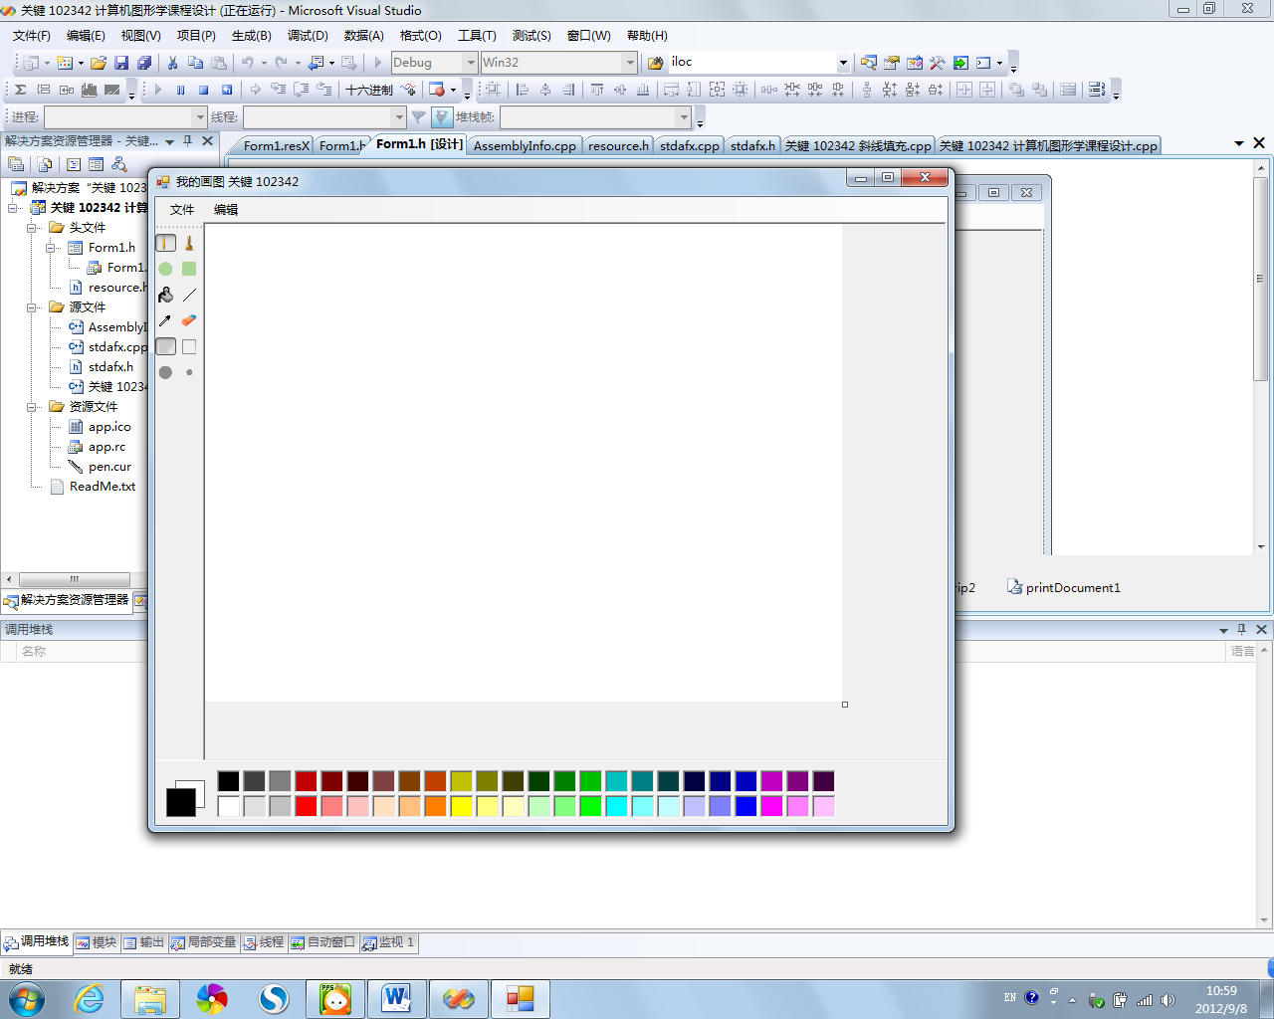
铅笔演示
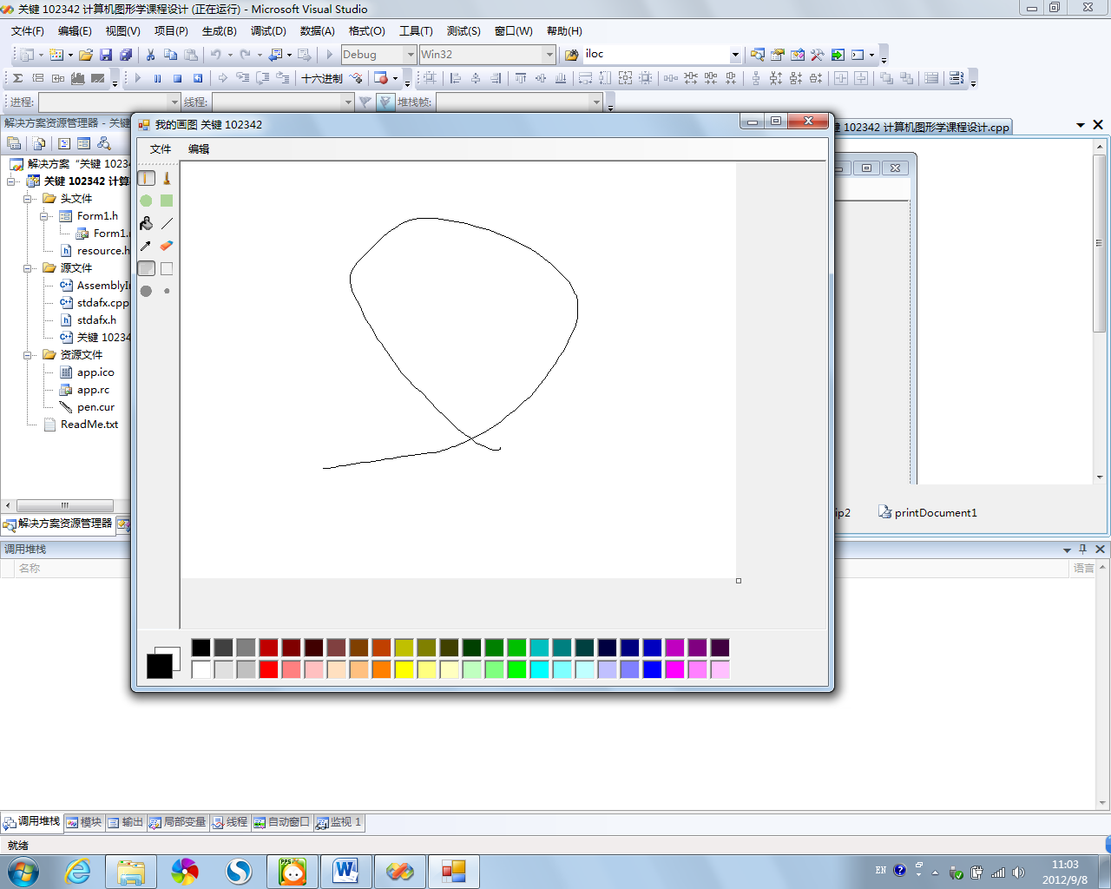
油漆桶演示
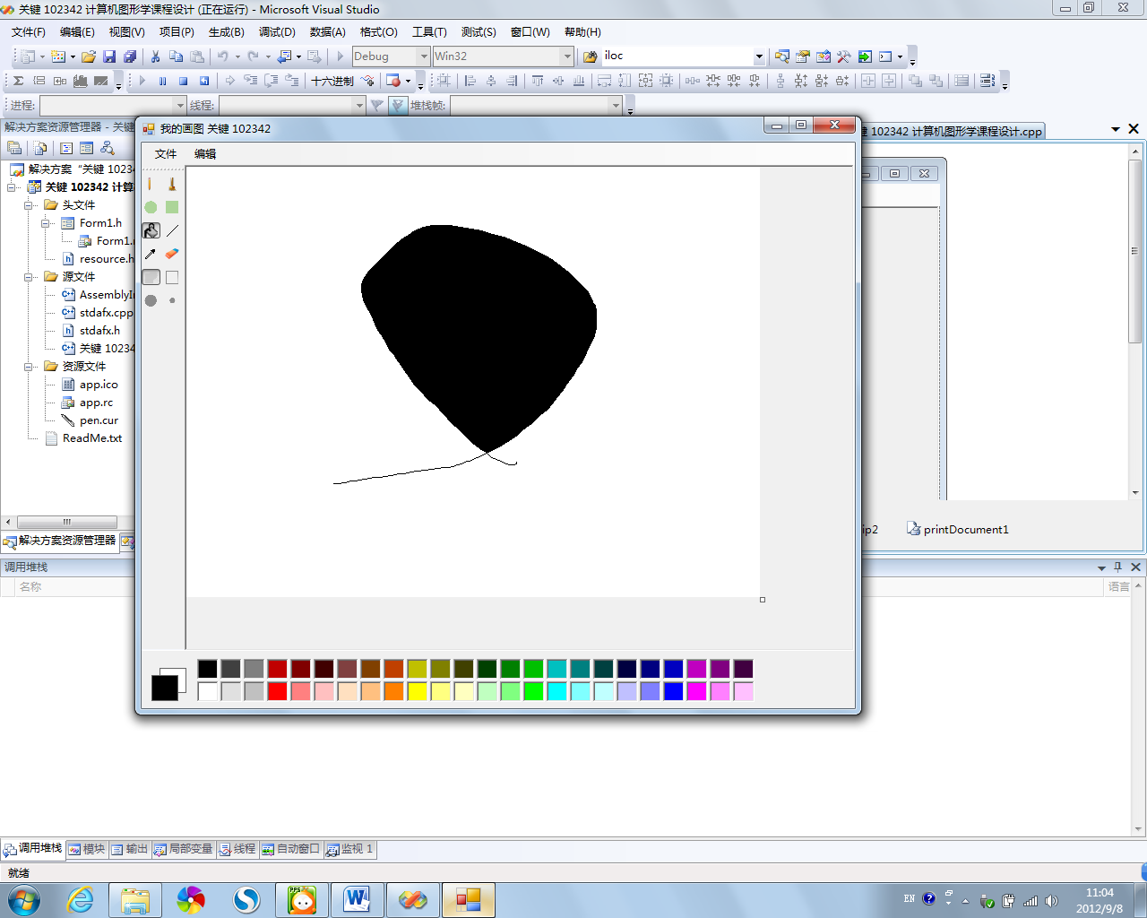
矩形（实心）演示
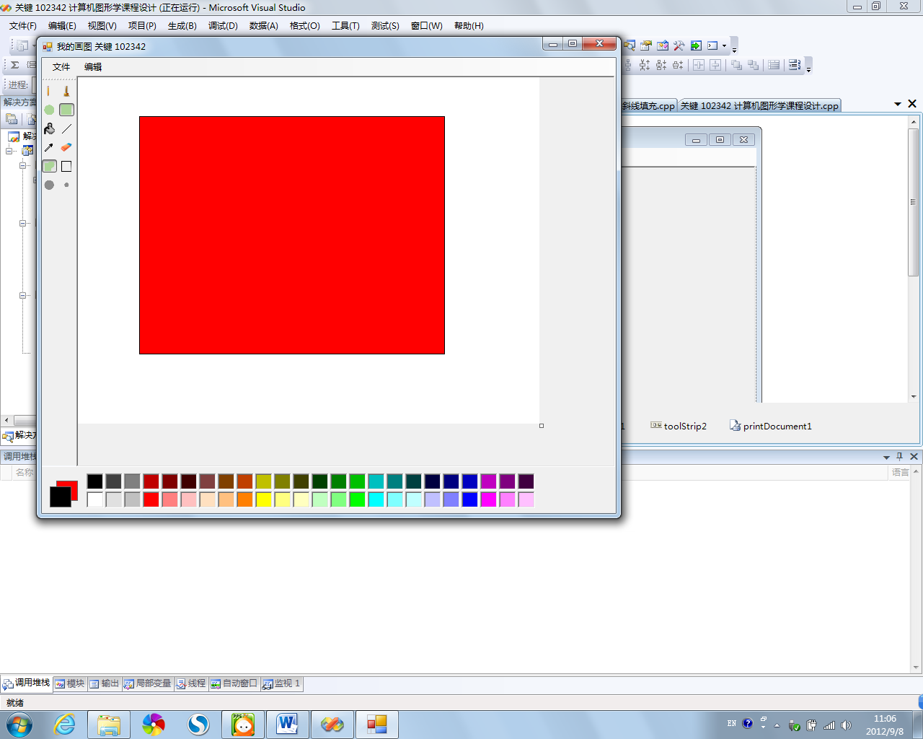
圆形（空心）演示
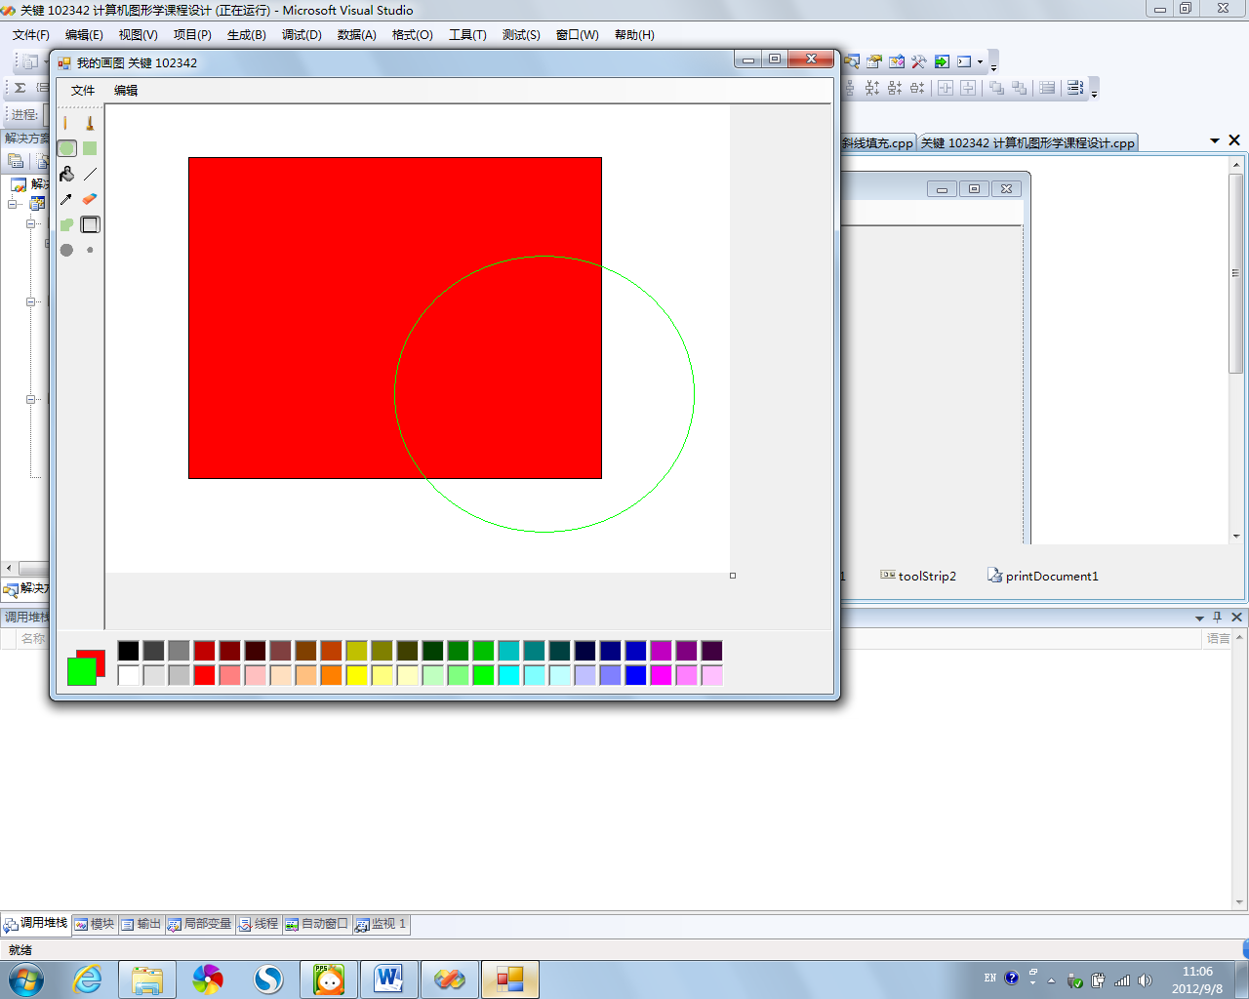
各种尺寸的刷子、橡皮
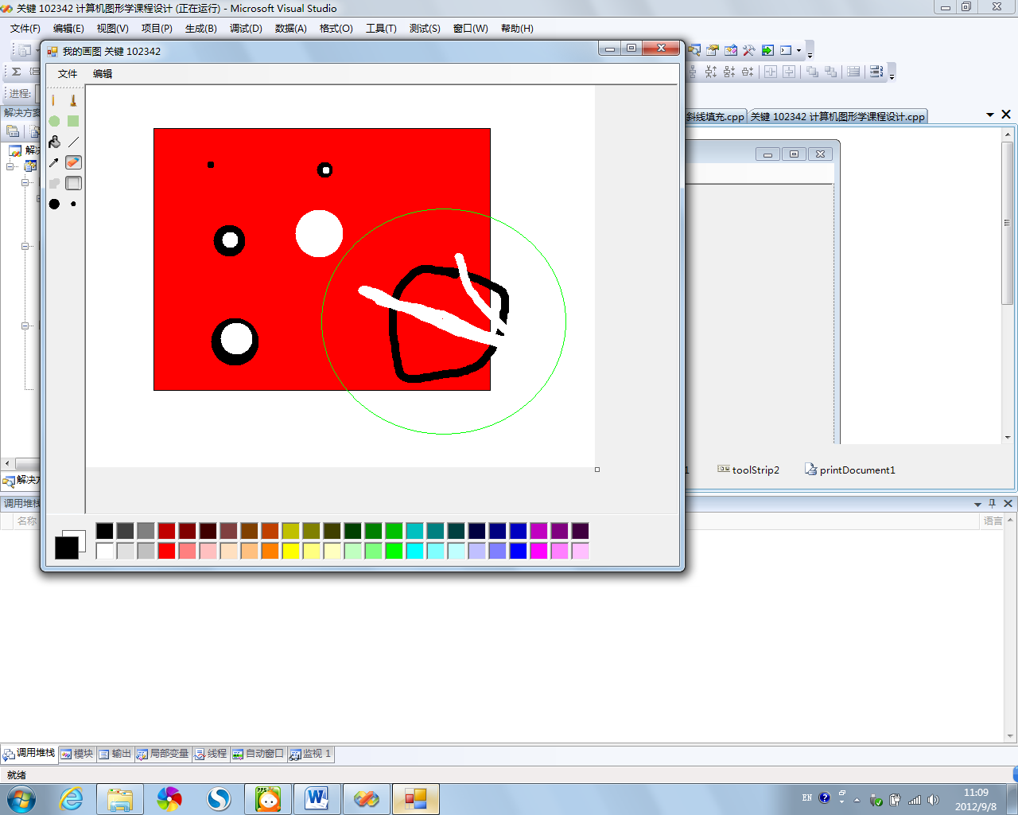
保存对话框
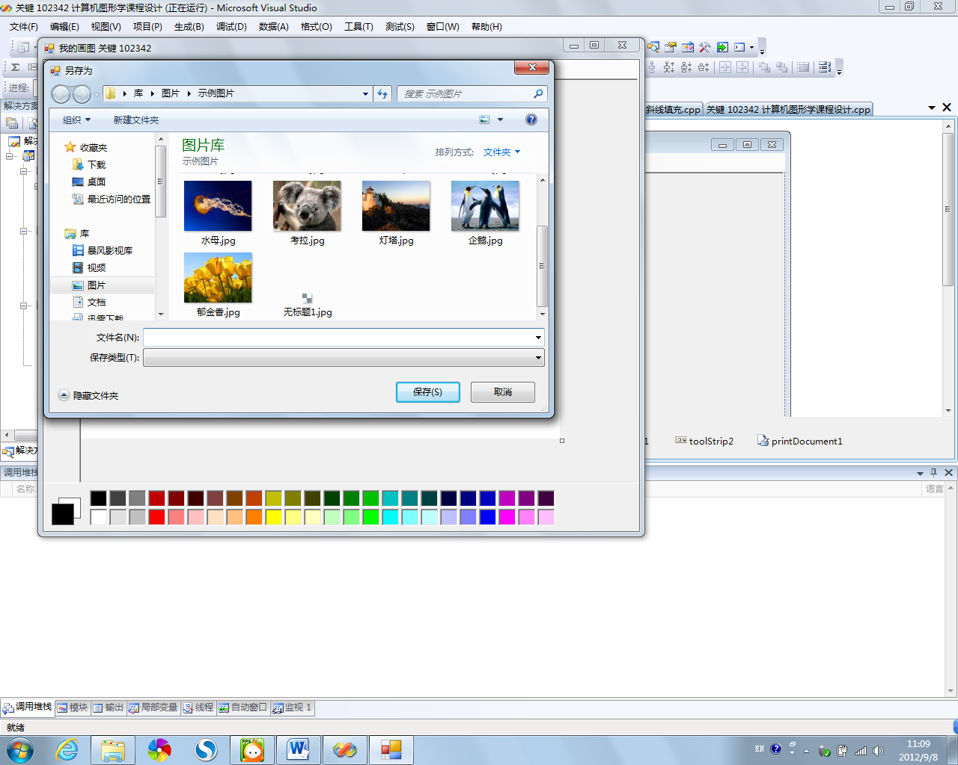
- 设计总结
这次设计令我受益匪浅，使我更加熟练的掌握了winform中有关图形和鼠标处理的部分，设计历时10天虽然比较累但是也充满了趣味和成就感，相信在这次设计中我获得的经验必然能在以后派上更大的用处。
- 参考文献
MSDN。

